**A. KPI’s**

**1. Total Revenue**

SELECT sum(total_price) AS Total_Revenue

FROM pizza_sales

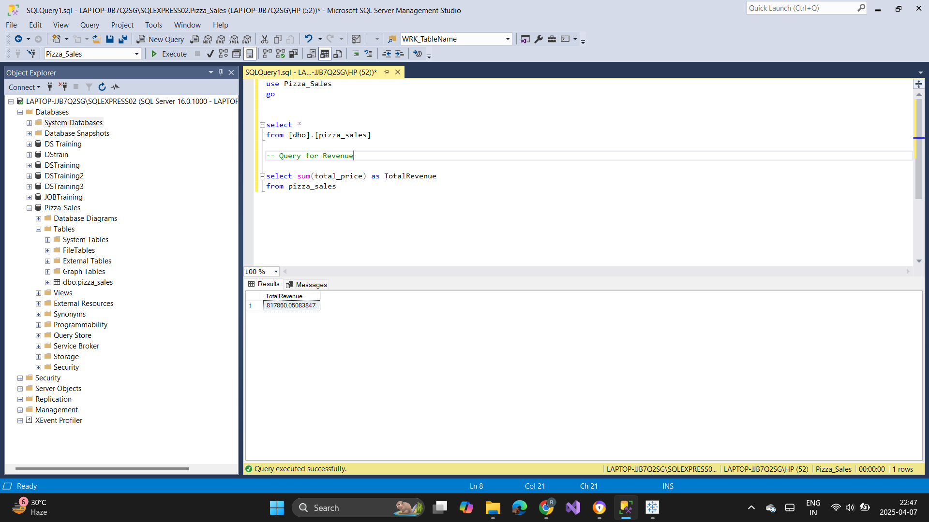

**2. Average Order Value**

SELECT SUM(total_price)/COUNT( DISTINCT order_id) AS Avg_Order_Value

FROM pizza_sales

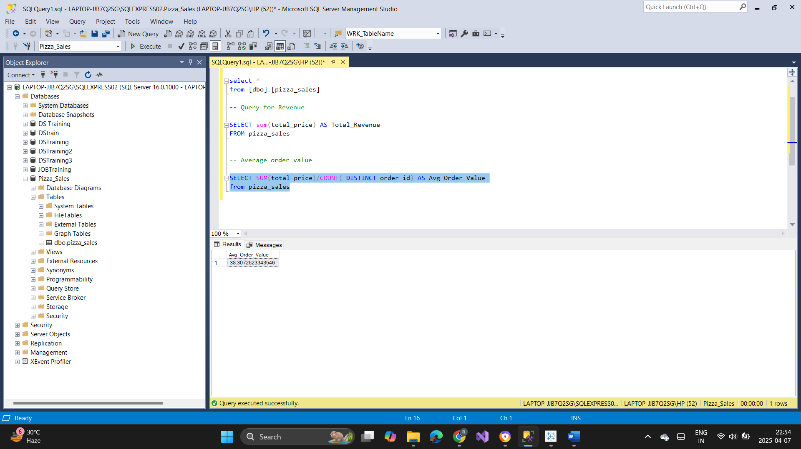

**3. Total Pizzas Sold**

SELECT SUM(quantity) AS Total_Pizza_Sold

FROM pizza_sales

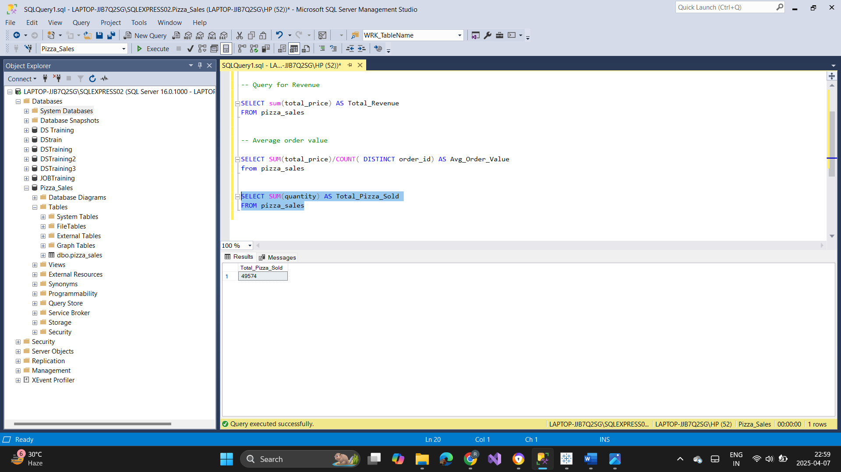

**4. Total Orders**

SELECT count(distinct order_id) AS Total_Order

FROM [dbo].[pizza_sales]

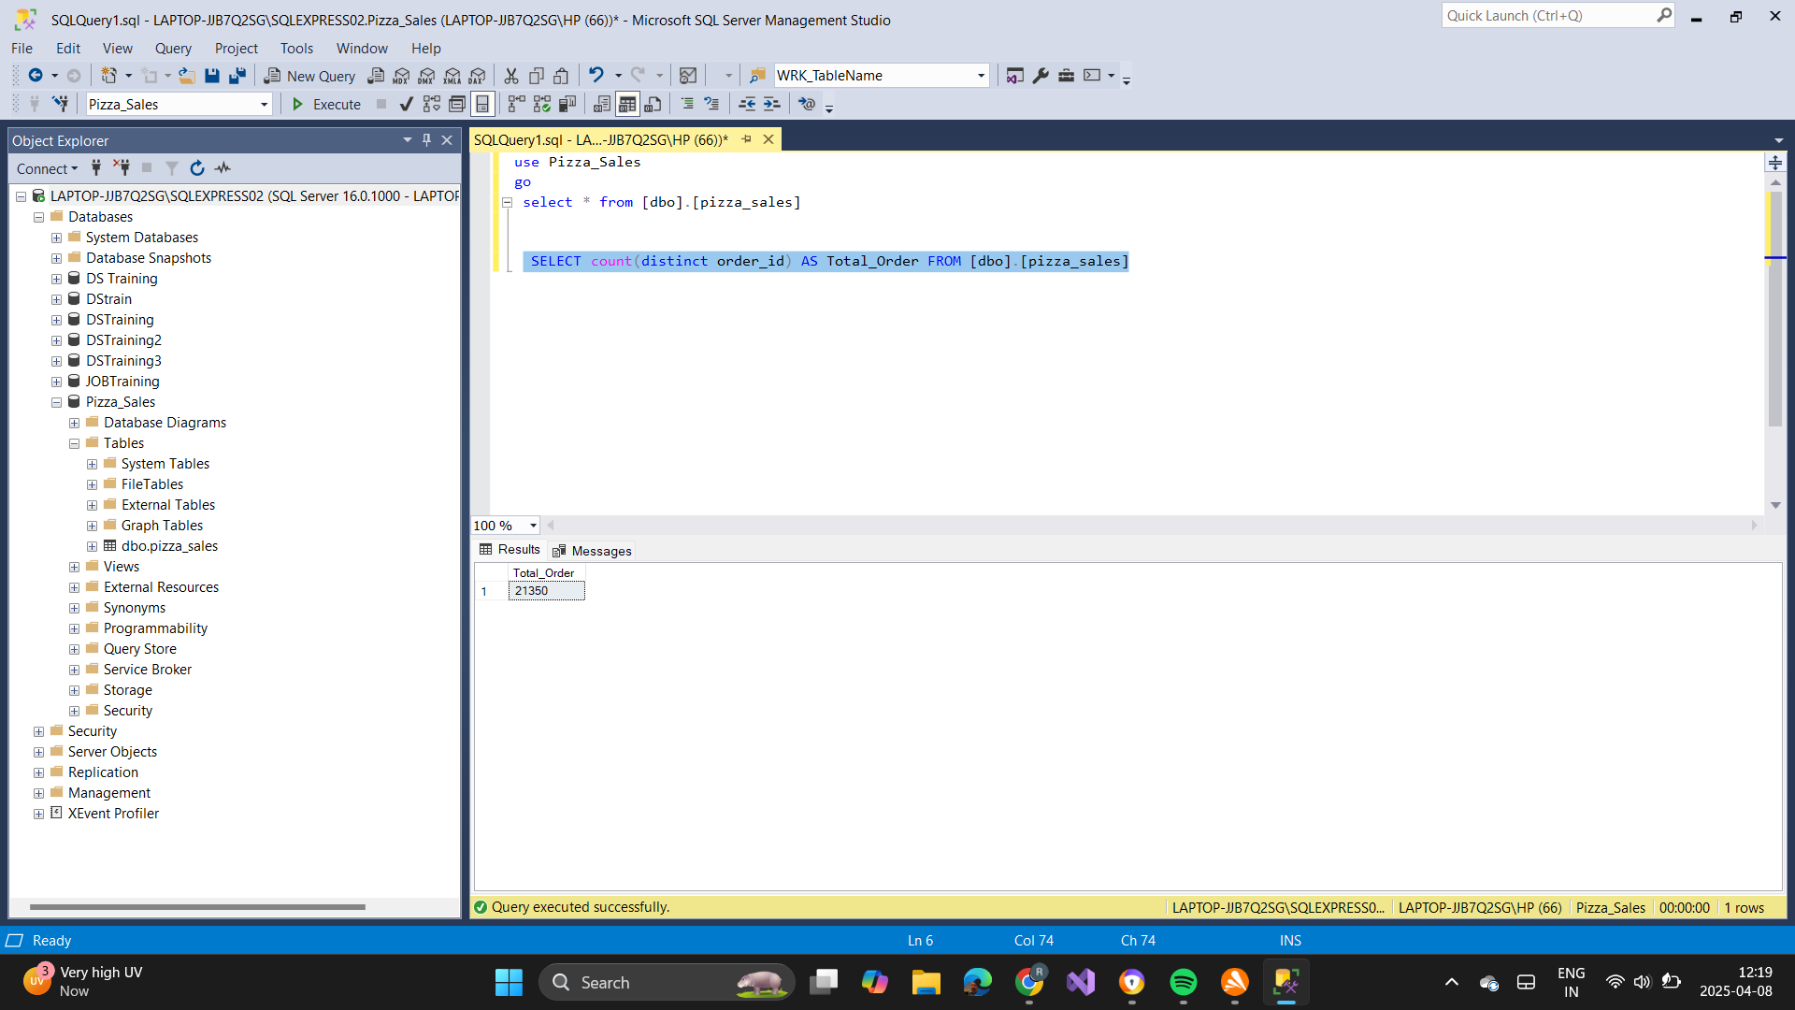

**5. Average Pizzas Per Order**

SELECT CAST(CAST(SUM(quantity)AS DECIMAL(10,2))/

CAST(COUNT(DISTINCT order_id)AS DECIMAL(10,2)) AS DECIMAL(10,2)) AS Avg_Pizzas_Per_Orders

FROM pizza_sales ??????

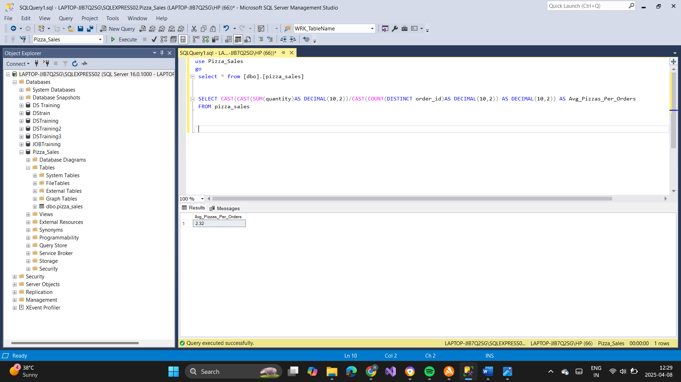

**B. Hourly trend in shop**

SELECT DATEPART(HOUR,order_time) AS order_hour, SUM(quantity) AS Total_Pizzas_Sold

FROM pizza_sales

GROUP BY DATEPART(HOUR,order_time)

ORDER BY DATEPART(HOUR,order_time);

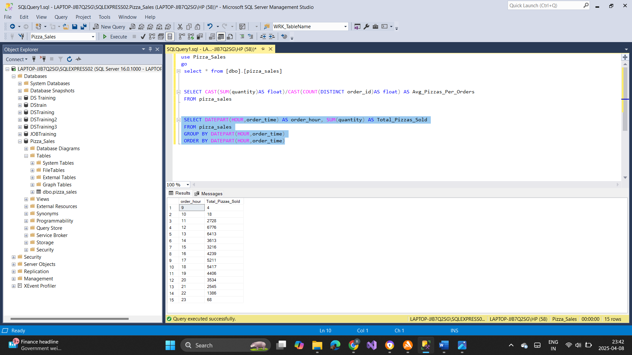

**C. Weekly trend for total orders**

SELECT DATEPART(ISO_WEEK, order_date) as Week_Number, YEAR(order_date) as Order_Year,

COUNT(Distinct order_id) as Total_orders FROM pizza_sales

GROUP BY DATEPART(ISO_WEEK, order_date), YEAR(order_date)

ORDER BY DATEPART(ISO_WEEK, order_date), YEAR(order_date)

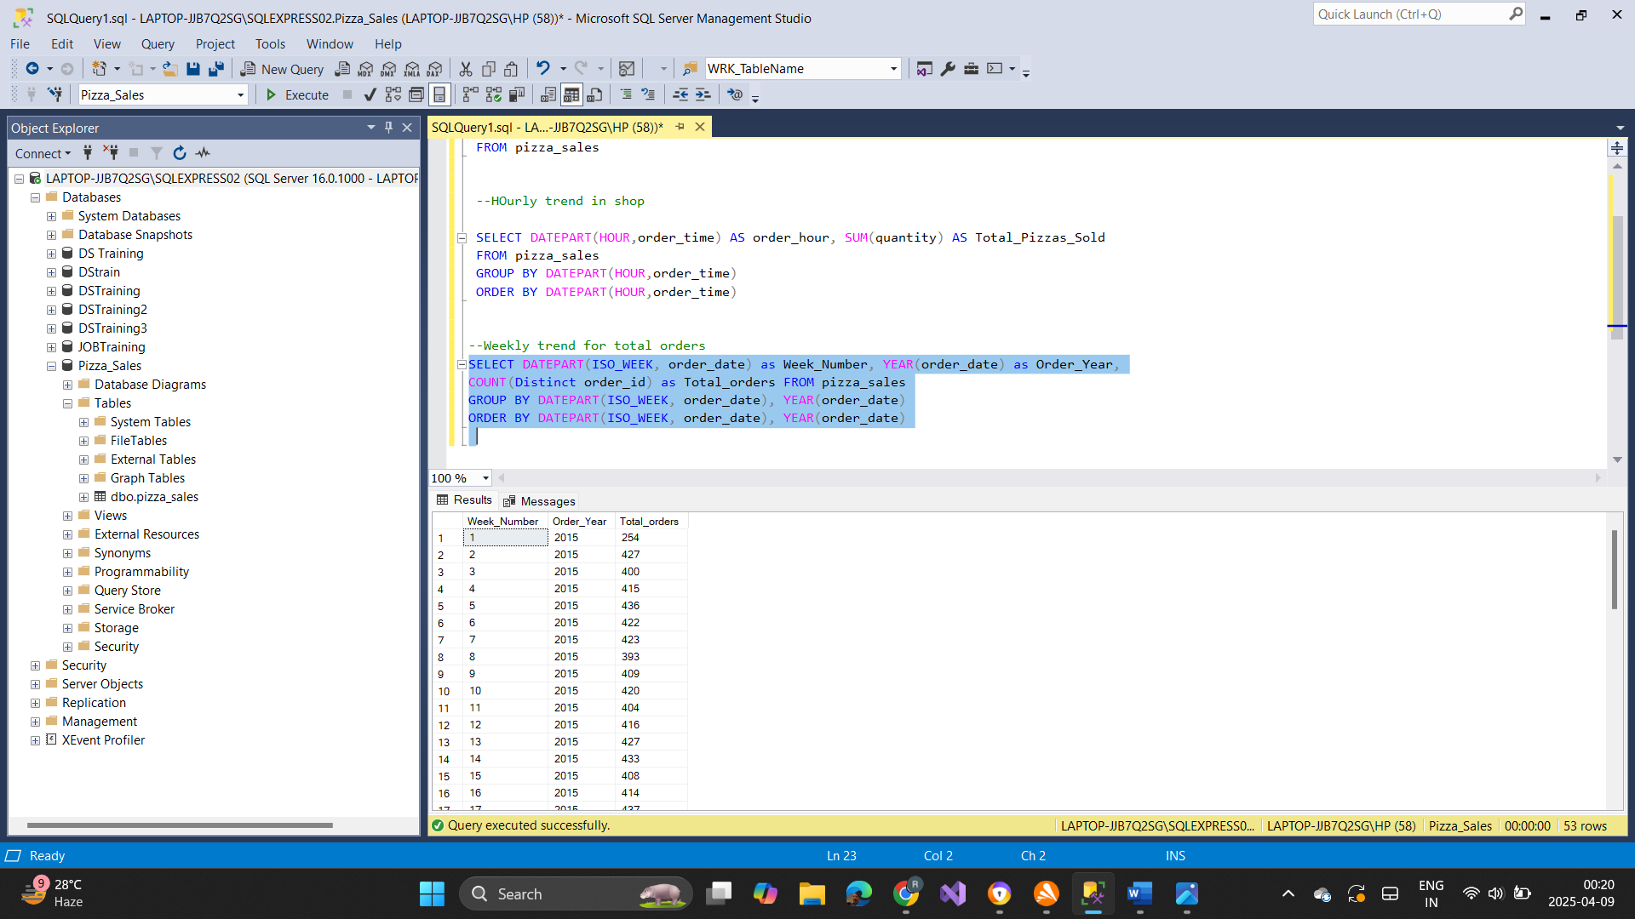 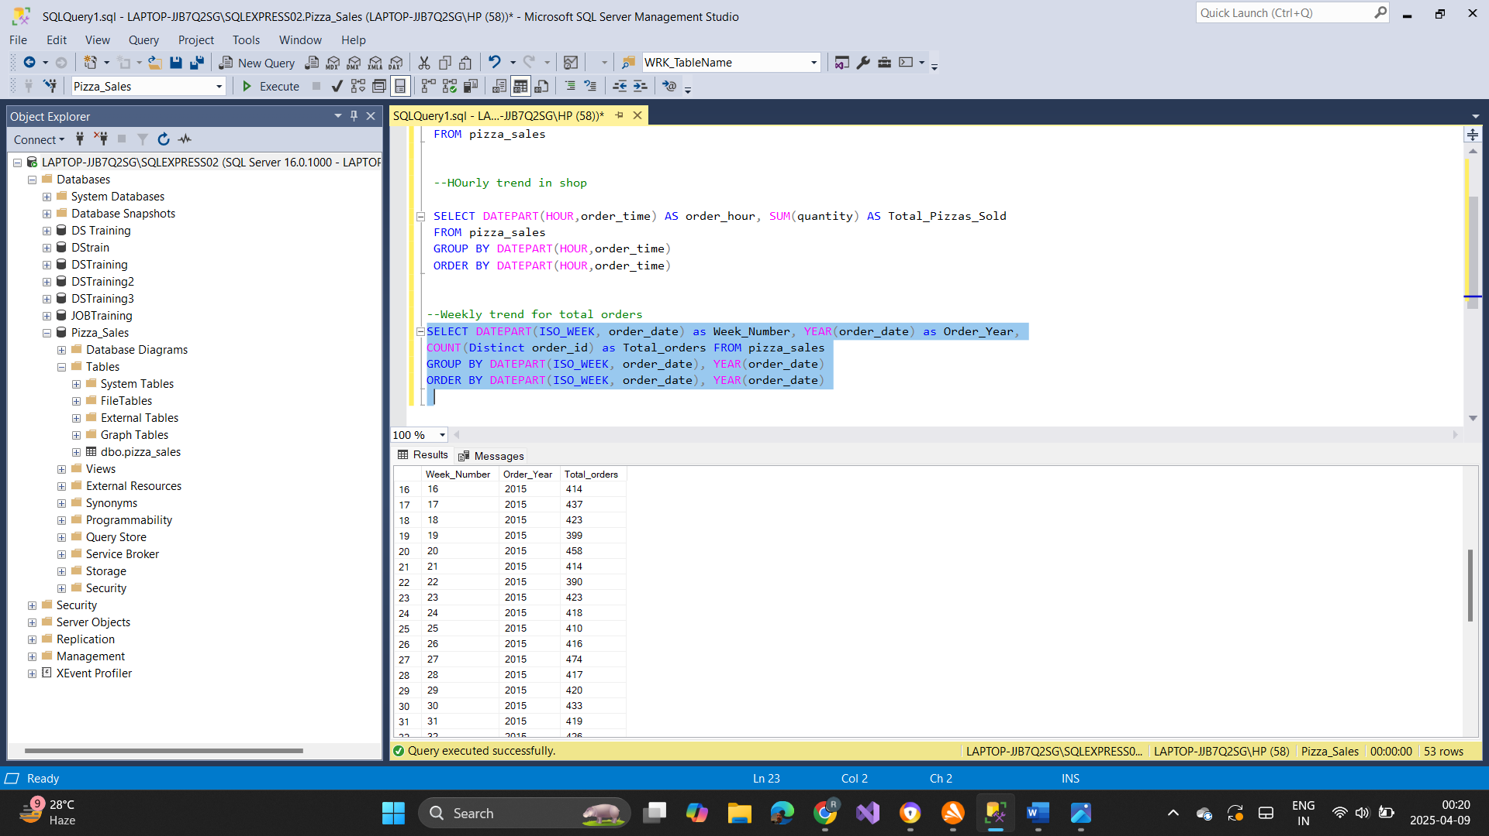

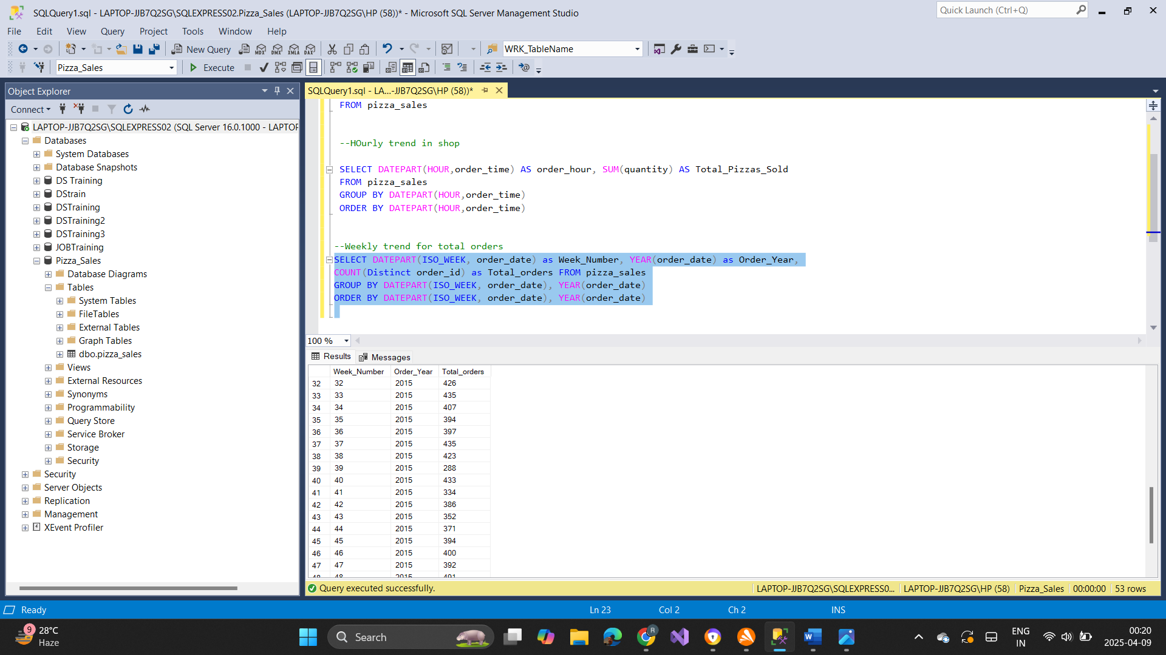 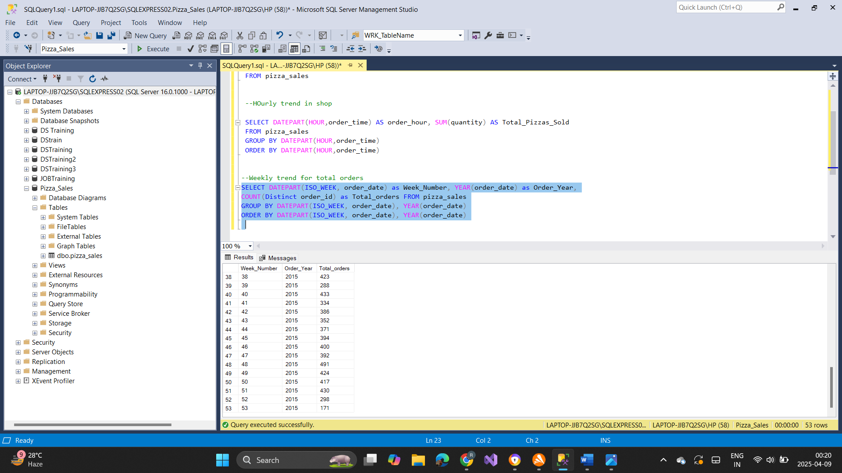

**D. Category wise Percentage sale**

SELECT pizza_category, SUM(total_price)AS Total_Sales, SUM(total_price)*100/(SELECT SUM(total_price) FROM pizza_sales) AS PCT

FROM pizza_sales

GROUP BY pizza_category

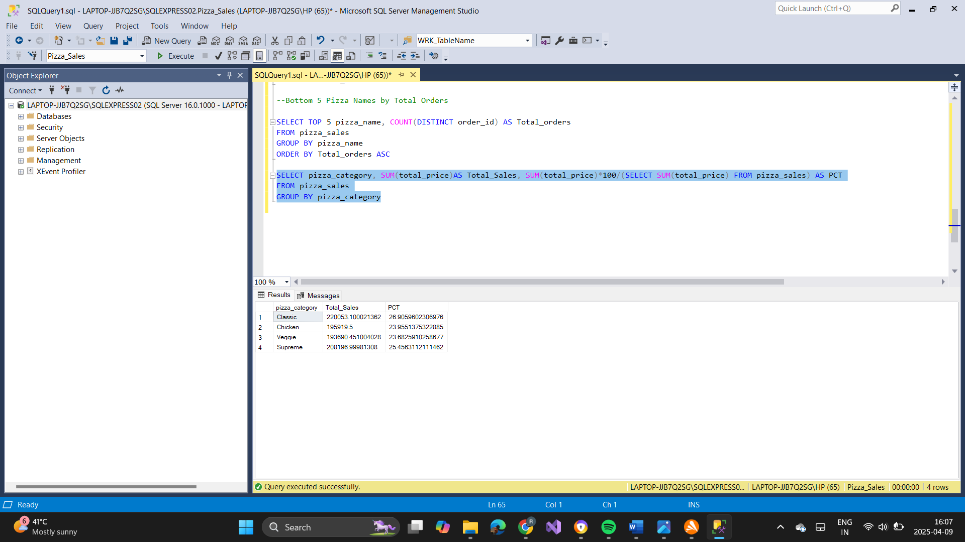

**E. Pizza size wise**

SELECT pizza_size, CAST(SUM(total_price) AS DECIMAL(10,2))AS Total_Sales, CAST(SUM(total_price)*100/(SELECT SUM(total_price) FROM pizza_sales) AS DECIMAL(10,2)) AS PCT

FROM pizza_sales

GROUP BY pizza_size

ORDER BY PCT DESC

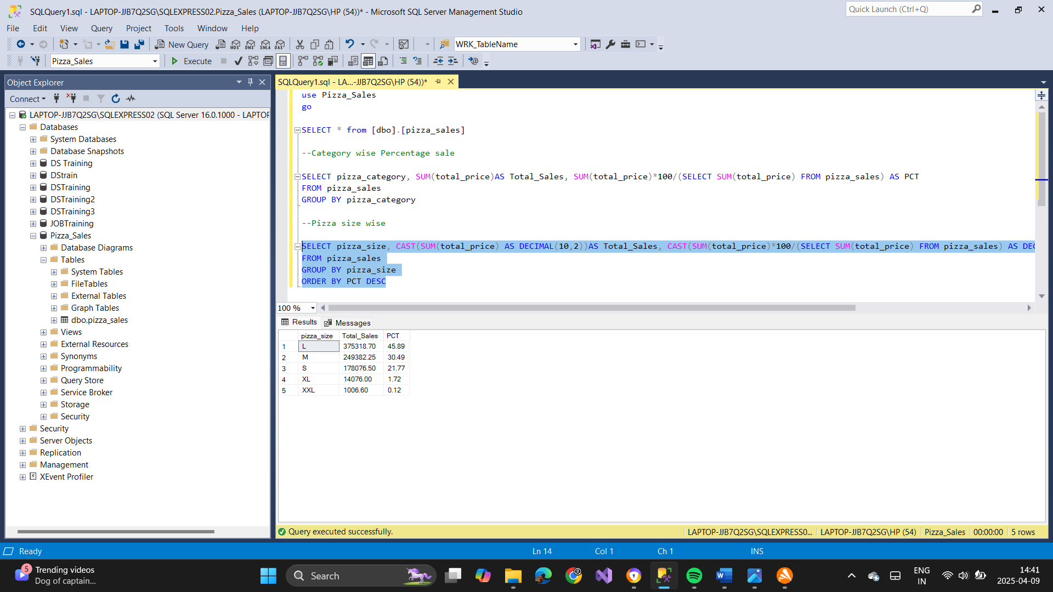

**F. Top 5 Pizza Names By Revenue**

SELECT TOP 5 pizza_name, SUM(total_price) AS Total_Revenue

FROM pizza_sales

GROUP BY pizza_name

ORDER BY Total_Revenue DESC

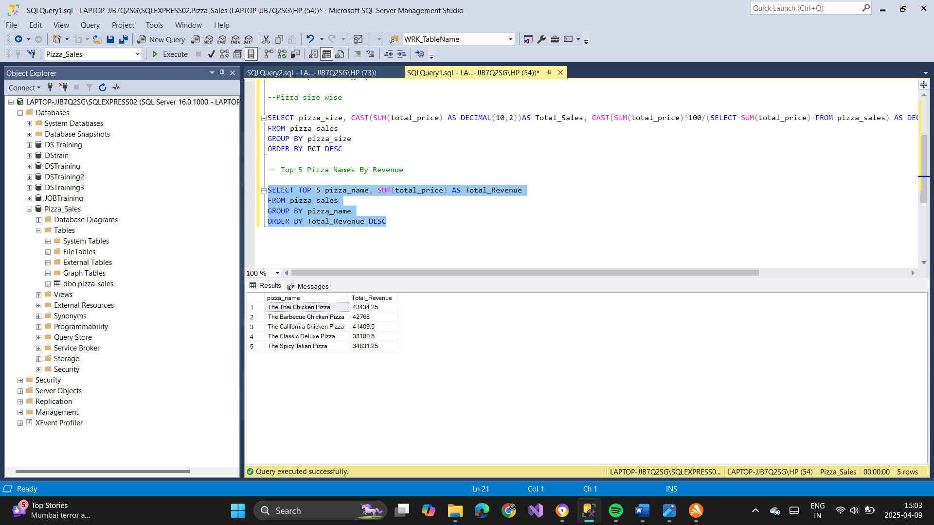

**G. Bottom 5 Pizza Names By Revenue**

SELECT TOP 5 pizza_name, SUM(total_price) AS Total_Revenue

FROM pizza_sales

GROUP BY pizza_name

ORDER BY Total_Revenue

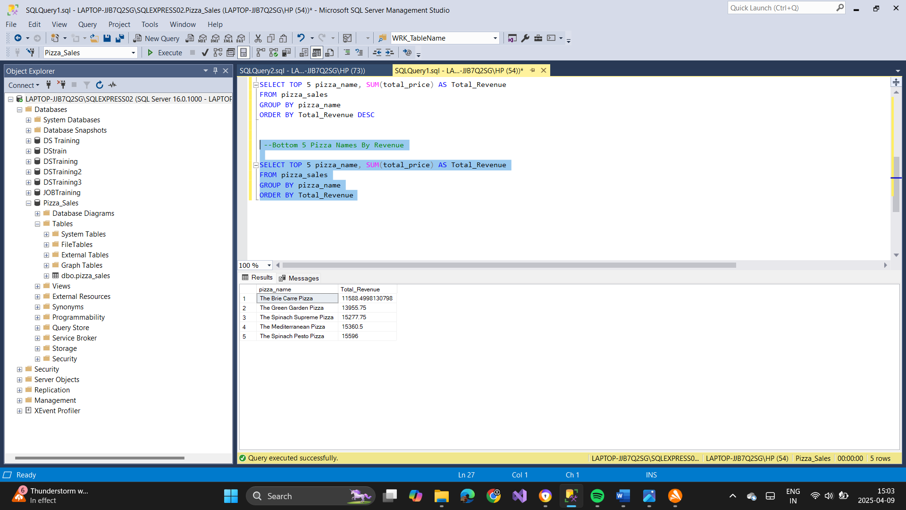

**H. Top 5 Pizza Names By Quantity**

SELECT TOP 5 pizza_name, SUM(quantity) AS Total_Pizzas_Sold

FROM pizza_sales

GROUP BY pizza_name

ORDER BY Total_Pizzas_Sold DESC

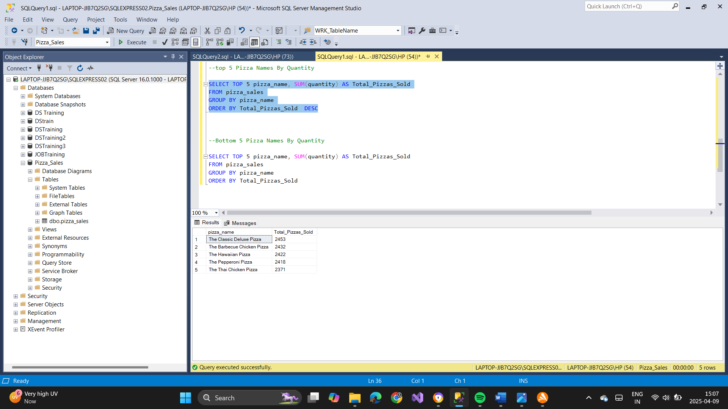

**I. Bottom 5 Pizza Names By Quantity**

SELECT TOP 5 pizza_name, SUM(quantity) AS Total_Pizzas_Sold

FROM pizza_sales

GROUP BY pizza_name

ORDER BY Total_Pizzas_Sold ASC

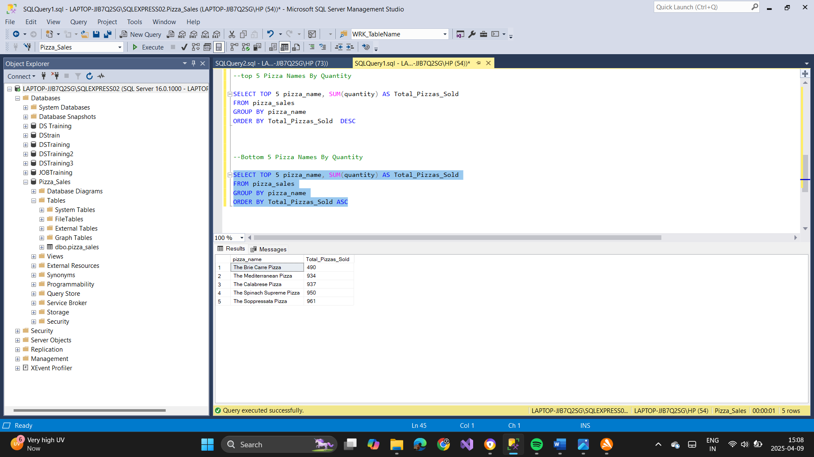

**J. Top 5 Pizza Names by Total Orders**

SELECT TOP 5 pizza_name, COUNT(DISTINCT order_id) AS Total_orders

FROM pizza_sales

GROUP BY pizza_name

ORDER BY Total_orders DESC

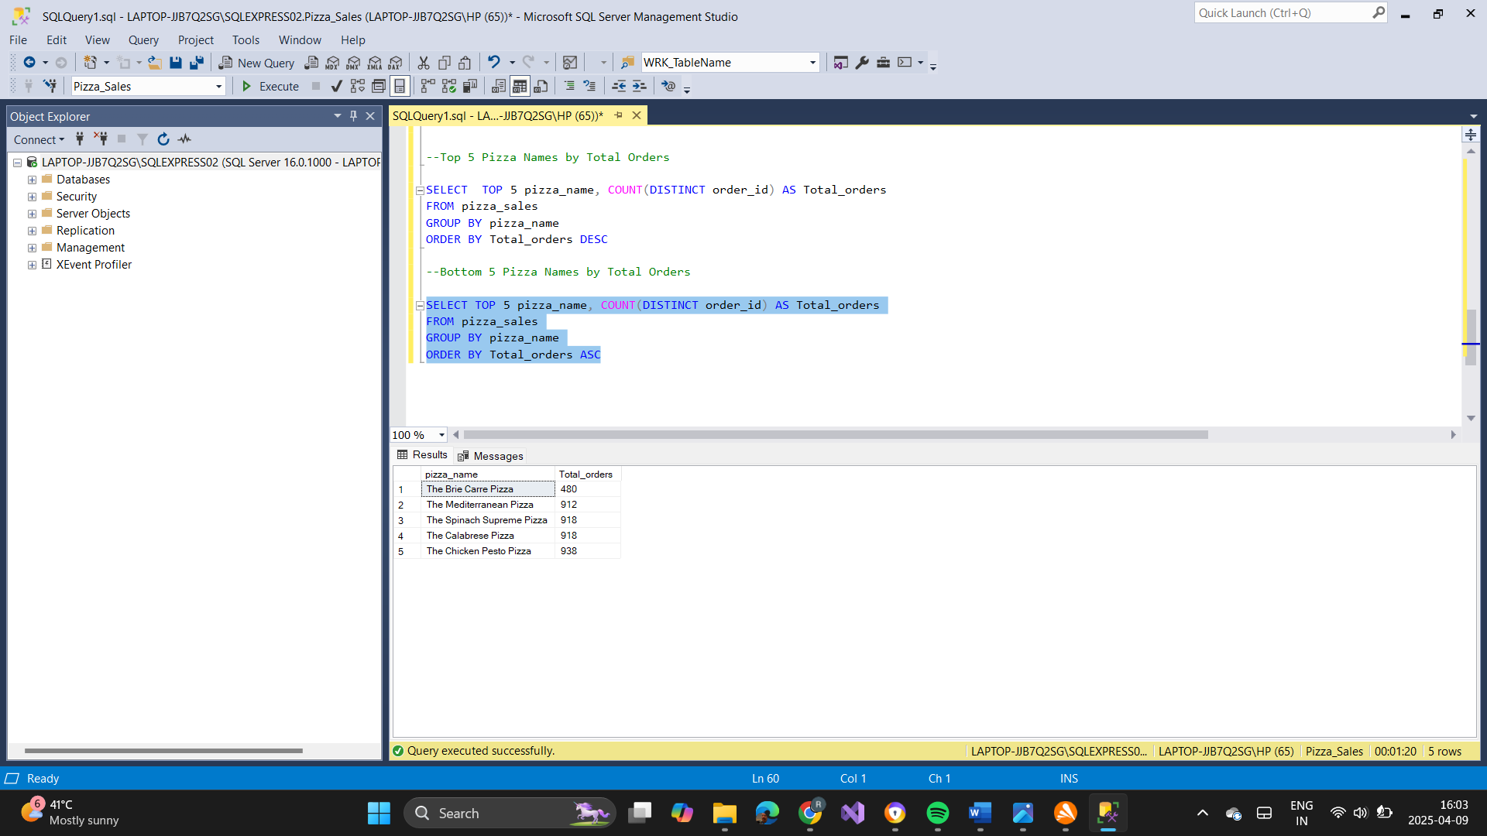

**K. Bottom 5 Pizza Names by Total Orders**

SELECT TOP 5 pizza_name, COUNT(DISTINCT order_id) AS Total_orders

FROM pizza_sales

GROUP BY pizza_name

ORDER BY Total_orders ASC

